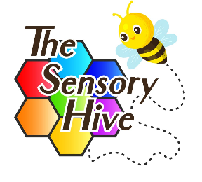
The Sensory Hive
Portable Hoist Client Usage Agreement

Client Name:
DOB (if under 18):
Address:
Parent / Carer (if under 18):
Mobile No:
Email:
Additional Carers’ Names:
Contact Details:
GP and Surgery:
Please list any important medical information which The Sensory Hive needs to be aware of to keep the client safe:
What are the Moving and Handling requirements for the client:
Approx Height and Weight: | Height: Weight:
Is the hoist similar to the one used at home? | Yes ☐ No ☐
Does the client have their own slings in place? | Yes ☐ No ☐  The client must have their own slings to use the portable hoist.
Name of person/s operating the portable hoist?
What is their role? | Family member ☐  Friend ☐  Carer/Agency ☐
Have they received Manual handling training within the last 12 months? | Yes ☐ No ☐  Only those who have been training in Manual Handling in the last 12 months should operate the portable hoist.
Are there any risk assessments in place which The Sensory Hive need to be made aware of to keep the client and others safe? | Yes ☐ No ☐  If yes, please email these to hello@thesensoryhive.co.uk
Any other relevant information:
AGREEMENT AND CONDITIONS OF USE
By signing this agreement, you confirm the following:
- You have read and understood the Portable Hoist Risk Assessment and agree to adhere to all safety procedures.
- You agree not to apply hoist brakes during transfers.
- Only the client’s own sling will be used.
- Transfers will always be carried out by two trained carers.
- The hoist will be charged when not in use, and slings and equipment will be checked for damage before use.
- You will not move the client between rooms in the hoist.
- All procedures will follow correct manual handling practices.
Client/Parent/Carer Name:
Signature:
Date:

