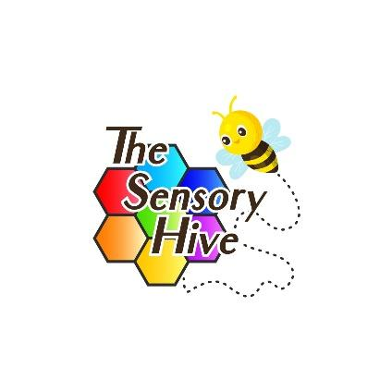

The Sensory Hive LTD
Volunteer Handbook and Agreement

Welcome to The Sensory Hive!
Thank you for choosing to volunteer with us. Volunteers are a vital part of our community, and we are excited to have you join our team. This handbook outlines what you can expect from us—and what we expect from you.

1. Our Mission
At The Sensory Hive LTD, we are committed to supporting children and young people with sensory and neurodevelopmental needs. Our goal is to create safe, inclusive, and therapeutic environments where everyone can thrive.

2. What You Can Expect from Us
- Induction and training relevant to your role.
- A supportive environment, including named staff supervision.
- Clear guidance and policies, including safeguarding and confidentiality.
- Recognition and appreciation for your contributions.
- Reimbursement of agreed expenses (e.g. travel), if applicable.

3. What We Expect from You
- Treat everyone with respect, empathy, and professionalism.
- Adhere to our policies, including:
  - Safeguarding
  - Health and Safety
  - Confidentiality
  - Equality, Diversity & Inclusion
- Be punctual and reliable. If you’re unable to attend, please inform us as early as possible.
- Participate in training and supervision.
- Support our values of inclusion, dignity, and well-being.

4. Volunteer Roles May Include:
- Supporting therapeutic activities
- Preparing sensory resources
- Helping with events or admin tasks
- Engaging with children and families under staff guidance
Note: You will never be asked to perform duties outside your skillset or without supervision.

5. Safeguarding and DBS
Safeguarding is everyone's responsibility. Volunteers must:
- Understand and follow our Safeguarding Policy.
- Report any concerns about a child, young person, or adult immediately to a designated safeguarding lead.
- Complete a Disclosure and Barring Service (DBS) check before working directly with children or vulnerable adults.

6. Health and Safety
You are responsible for:
- Following safety procedures.
- Reporting hazards, accidents, or incidents.
- Wearing any required protective equipment.
- Participating in emergency procedures (e.g., fire drills).

7. Confidentiality
Any personal or sensitive information you come across must be treated as strictly confidential and must not be shared outside of The Sensory Hive unless authorised or required by law.

8. Ending Your Volunteering
You may stop volunteering at any time. We ask for as much notice as possible. We’ll also give you the chance to provide feedback and receive a reference, if appropriate.

Volunteer Agreement
This agreement sets out the mutual expectations between The Sensory Hive LTD and the volunteer. It is not a legally binding contract, but an outline of responsibilities.

Volunteer Details
Full Name:
Address:
Phone:
Email:
Emergency Contact Name & Number:

Declaration
I agree to:
- Follow The Sensory Hive LTD's policies and procedures.
- Treat clients, staff, and other volunteers with respect.
- Keep all information confidential.
- Prioritise safeguarding and report any concerns.
- Attend training and supervision as required.

I understand that this is a voluntary role and not a contract of employment.

Signed (Volunteer): ______________________________
Date: ___________________

Signed on behalf of The Sensory Hive: ______________________________
Role: ____________________________
Date: ___________________

