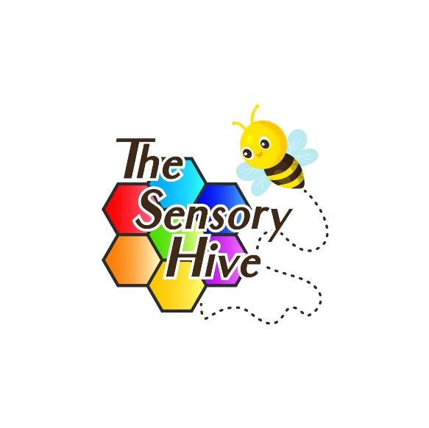

Video and Photo Policy
The Sensory Hive Ltd

Date: 18/5/25 | The Sensory Hive LTD | Address: Weyman Avenue, L35 2YW
Review Date:  18/5/26 | Ref: The Sensory Hive Video and Photo Policy | Assessor: Hayley Peden
Amended on:  Review Date | New Ref/Version: | Signed:
Amended on:  Review Date | New Ref/Version: | Signed:
Amended on:  Review Date | New Ref/Version: | Signed:

1. Purpose
This policy sets out how The Sensory Hive Ltd collects, uses, stores, and shares photographs and video recordings of individuals, including children and vulnerable persons, during its services, sessions, events, or activities. It ensures that all use of such media is lawful, ethical, and respects individuals’ rights to privacy and consent.

2. Scope
This policy applies to:
- All staff, volunteers, contractors, and visitors at The Sensory Hive Ltd.
- All forms of photography and video recording (digital, print, online).
- All individuals whose images may be captured (including children, parents, carers, and staff).

3. Legal Framework
The policy is guided by the following:
- UK General Data Protection Regulation (UK GDPR)
- Data Protection Act 2018
- Children Act 1989
- Protection of Freedoms Act 2012

4. Consent
- Explicit consent must be obtained before taking or using any photographs or video recordings of individuals.
- Consent is gathered using the official Video and Photo Consent Form.
- For individuals under 18, written consent from a parent or legal guardian is required.
- Consent can be withdrawn at any time by contacting The Sensory Hive Ltd.

5. Use of Photos and Videos
Photos and videos may be used for:
- Promotional materials (e.g., brochures, posters)
- Social media posts (e.g., Facebook, Instagram)
- Company website and blog
- Press releases and media coverage
- Training and educational purposes
No personal data (e.g., names) will be published alongside images without further explicit permission.

6. Storage and Retention
- Images and videos will be stored securely on password-protected devices or encrypted cloud storage.
- Access is restricted to authorized personnel only.
- Media will be retained for a maximum of 5 years unless consent is renewed or revoked earlier.
- Files will be securely deleted upon expiry of the retention period or withdrawal of consent.

7. Safeguarding
- Photographs and videos of children and vulnerable individuals will always be used sensitively and respectfully.
- The Sensory Hive Ltd will avoid taking or sharing images that could be seen as inappropriate or put individuals at risk.
- No unauthorized photography or filming is permitted on-site by visitors.

8. Breaches and Complaints
Any breach of this policy will be taken seriously and investigated promptly. Complaints or concerns should be directed to:
Data Protection Lead:
Hayley Peden
Hayley@thesensoryhove.co.uk
07725 130794

9. Policy Review
This policy will be reviewed annually or sooner if legislation or business practices change.

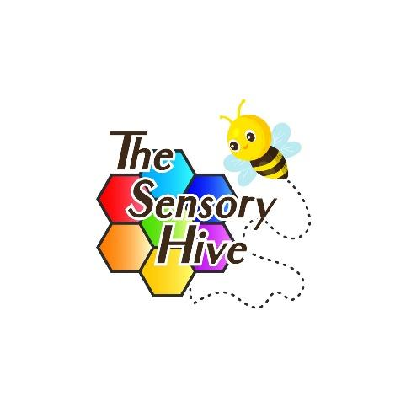

VIDEO AND PHOTO CONSENT FORM
The Sensory Hive Ltd
Registered Company Number:
Address: Weyman Ave, Liverpool, L35 2YW

Purpose of Consent:
The Sensory Hive Ltd occasionally takes photographs and records videos of participants, staff, and visitors during activities, events, and sessions. These images may be used for marketing, promotional materials, social media, websites, training, or internal documentation. We seek your consent to use images and/or video footage where you or your child may be identifiable.

Consent Details:
Name of Participant (or Child): __________________________________________________________________
Date of Birth (if under 18): __________________________________________________________________
Name of Parent/Guardian (if under 18): __________________________________________________________________

Please tick to confirm:
☐ I give consent for photographs and videos to be taken of me / my child by The Sensory Hive Ltd.
☐ I give consent for these photographs and videos to be used for:
☐ Website
☐ Social Media (e.g., Facebook, Instagram, TikTok)
☐ Printed materials (flyers, brochures, posters)
☐ Training purposes
☐ Press releases / Media articles

☐ I understand that I can withdraw my consent at any time by contacting The Sensory Hive Ltd.

Signature of Participant / Parent / Guardian:
___________________________________________________________________
Date: ___________________________________________________________________
Contact Email / Phone (optional for withdrawal of consent): ___________________________________________________________________

Notes:
- All images and videos will be used respectfully and in accordance with data protection regulations (e.g., UK GDPR).
- No names will be published alongside images without explicit written permission.
- You may request access to or deletion of any media that features you or your child.

